Assignment 9:

# Class Diagram:

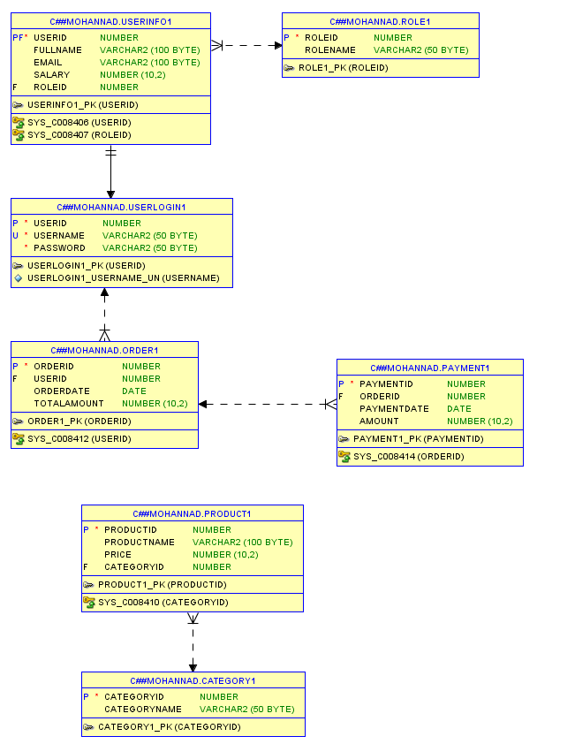

1- Display user information by username and password:

create or replace procedure display_user(username in varchar2, password in varchar2)

is

v_fullname VARCHAR2(100);

v_email VARCHAR2(100);

v_salary NUMBER;

v_roleid NUMBER;

begin

select userinfo1.fullname, userinfo1.email, userinfo1.salary, userinfo1.roleid

into v_fullname, v_email, v_salary, v_roleid

from userinfo1

inner join userlogin1 on userinfo1.userid = userlogin1.userid

where userlogin1.username = username AND userlogin1.password = password;

DBMS_OUTPUT.PUT_LINE('Full Name: ' || v_fullname);

DBMS_OUTPUT.PUT_LINE('Email: ' || v_email);

DBMS_OUTPUT.PUT_LINE('Salary: ' || v_salary);

DBMS_OUTPUT.PUT_LINE('Role ID: ' || v_roleid);

end display_user;

BEGIN

display_user('user1', 'pass1');

END;

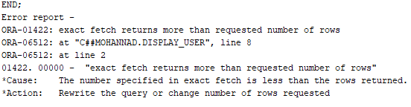

I kept getting this error, which indicates that multiple rows were fetched, I checked the logic and it seems fine, only the user who’s info was entered as parameter should be returned.

2- Display All Product Names and Prices:

create or replace procedure display_all_products

is

v_product_name varchar2(100);

v_price number;

begin

for product_record in (select productname, price from Product1) loop

DBMS_OUTPUT.PUT_LINE('Product Name: ' || product_record.productname || ' | Price: ' || product_record.price);

end loop;

end display_all_products;

BEGIN

display_all_products;

END;

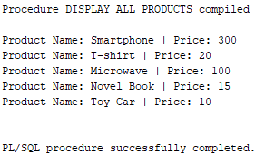

3- Display Products by Product Name:

create or replace procedure display_products_by_name(product_name in varchar2)

is

v_product_name VARCHAR2(100);

v_price NUMBER;

begin

for product_record in (

select productname, price

from Product1

where productname = product_name

) loop

DBMS_OUTPUT.PUT_LINE('Product Name: ' || product_record.productname || ' | Price: ' || product_record.price);

end loop;

END display_products_by_name;

BEGIN

display_products_by_name('Smartphone');

END;

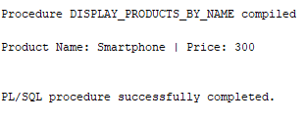

4- Display Products by Price:

create or replace procedure display_products_by_price(min_price in number, max_price in number)

is

v_product_name varchar2(100);

v_price number;

begin

for product_record in (

select productname, price

from Product1

where price between min_price AND max_price

) LOOP

DBMS_OUTPUT.PUT_LINE('Product Name: ' || product_record.productname || ' | Price: ' || product_record.price);

END LOOP;

END display_products_by_price;

BEGIN

display_products_by_price(12, 200);

END;

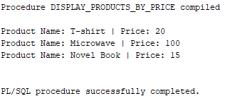

5- Display Users with Their Roles

create or replace procedure display_users_with_roles

is

v_fullname varchar2(100);

v_email varchar2(100);

v_role_name varchar2(100);

begin

for user_record in (

select userinfo1.fullname, userinfo1.email, role1.rolename

from userinfo1

inner join role1 on userinfo1.roleid = role1.roleid

) LOOP

DBMS_OUTPUT.PUT_LINE('Full Name: ' || user_record.fullname ||

' | Email: ' || user_record.email ||

' | Role: ' || user_record.rolename);

END LOOP;

END display_users_with_roles;

BEGIN

display_users_with_roles;

END;

